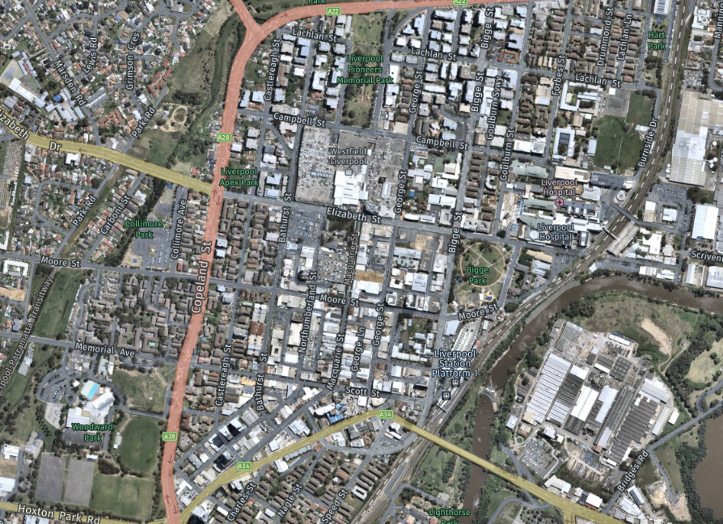

Liverpool City Centre

**Site**

Hume Highway